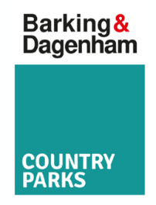
Self-led visit enquiry/booking form
Please note: If you would like to book for multiple classes/groups, we ask that you complete a separate booking form for each class/session. Thank you.

Your Name:
Email:
Your work phone number:
School or organisation name:
Address:

Post Code:
Which park/nature reserve would you like to visit?
What is your preferred choice of date?
Please give backup date(s) in case your preferred date is not available:
Preferred start time: | Preferred end time:
Year group / Key Stage / Other group:

Number of Children / Adults:
Any SEND/access needs? (Including any access needs for adults accompanying the group):
Has your school / group visited an LBBD park before? (Please provide details if you have them)

Contact name for invoice:
Email address for invoice:

Please send your completed form enquiry to Rangers@lbbd.gov.uk
Thank you

